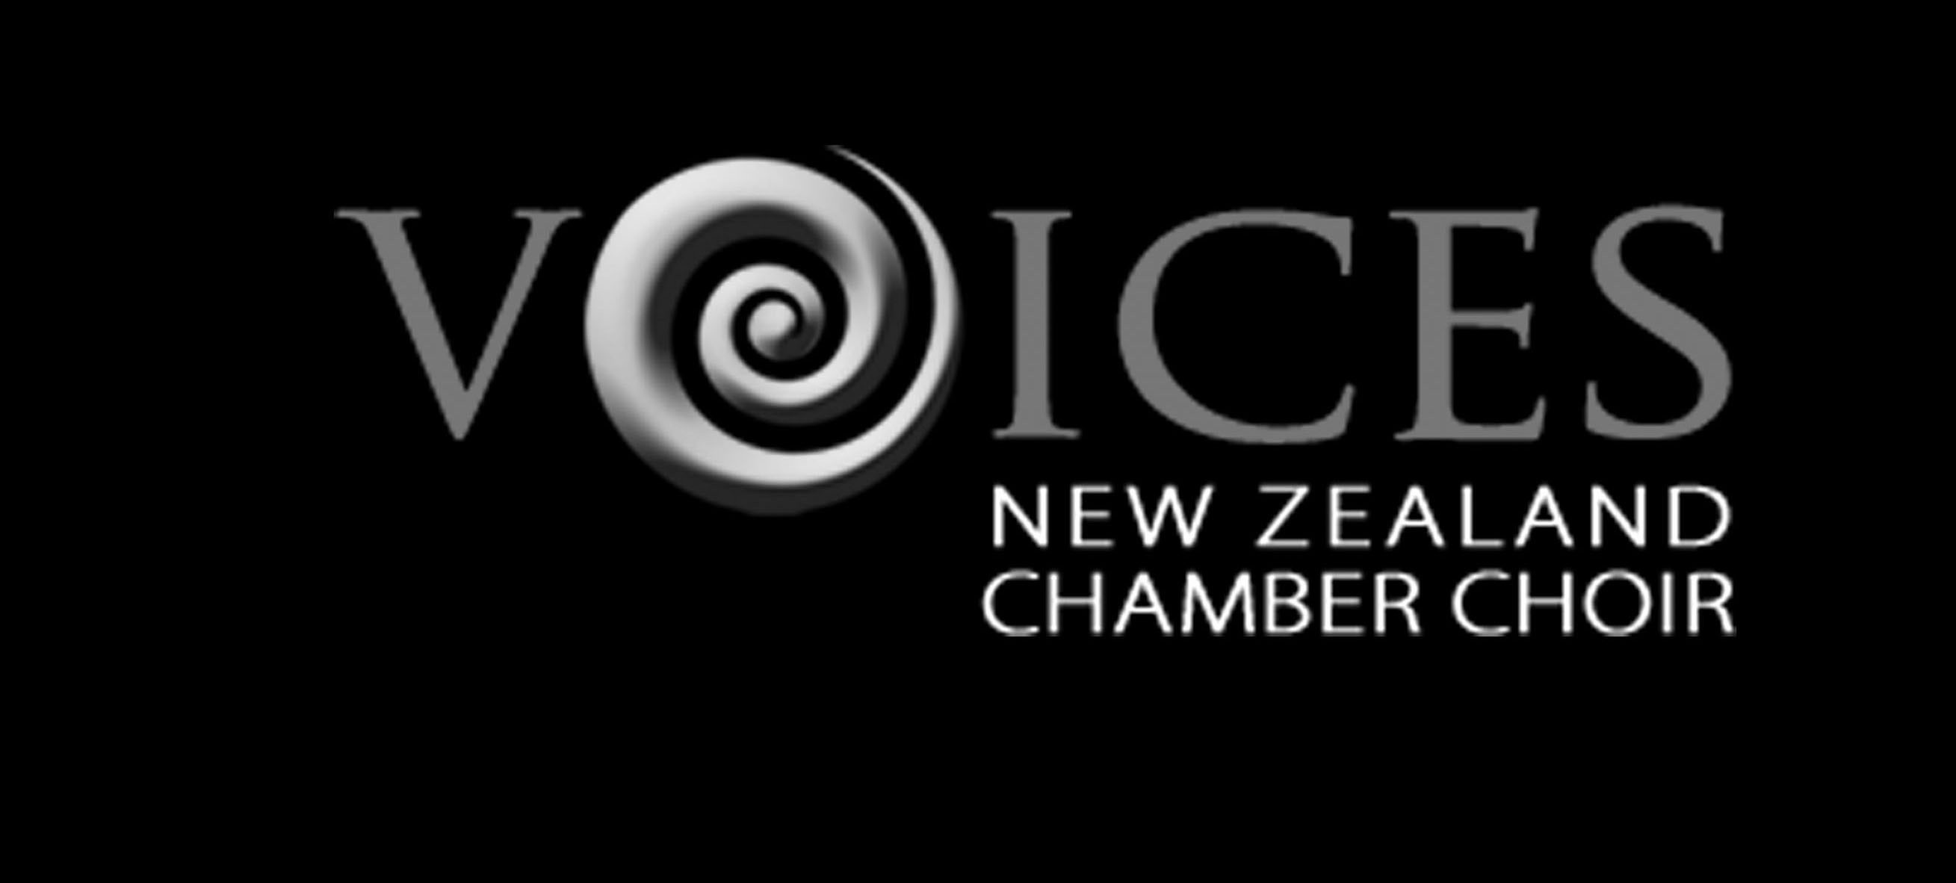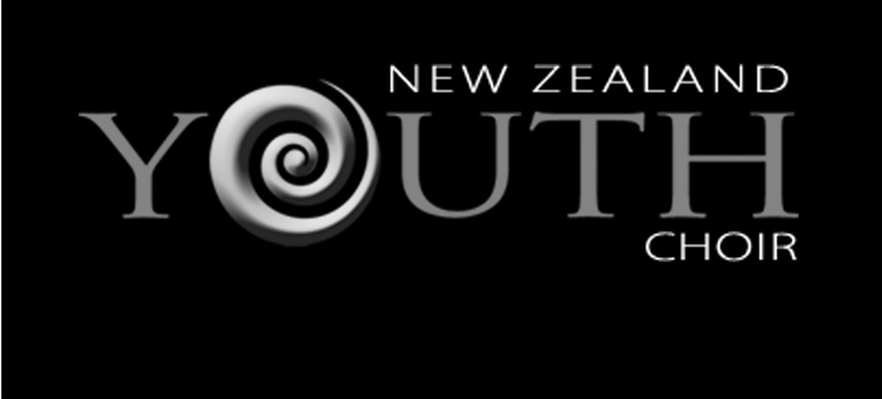

VOICES NEW ZEALAND PRESS RELEASE
14 March 2011. For immediate release

World-Renowned Choral Director Hands on the Baton

Choirs Aotearoa New Zealand is seeking new talent to lead the internationally famous New Zealand Youth Choir.

The NZYC will trial two applicants for the choir director job during its rehearsal and concert courses in July and August/September.

Karen Grylls, as Artistic Director of Choirs Aotearoa New Zealand since 1989 has conducted both the NZ Youth Choir and Voices New Zealand Chamber Choir in this role.

The NZYC has seen sustained international success and top-level music making during her tenure, Grylls says. However she wishes to see young conductors have the chance to further their experience alongside leading international professionals.

“A new Music Director for Youth Choir will ensure the level of choral excellence continues, while at that same time bringing fresh ideas and experiences to the national choirs,” Grylls says.

While retaining an advisory role with the Youth Choir, the restructuring of Choirs Aotearoa allows Grylls to concentrate on developing their flagship ensemble, the Voices New Zealand Chamber Choir.

“My vision, to see Voices NZ as a professional choral ensemble alongside other professional arts organisations, is paramount for me. This new position will allow me the time and focus that I need to explore opportunities for choral singers to be working professionally on national and international platforms.”

Voices is made up of nationally-selected singers, many of whom gained their choral training in the NZYC.

Choirs Aotearoa Chief Executive Officer Roger Lloyd says the whole point about both choirs is that they are truly national. “They involve singers from all over the country, and they tour all over the country and overseas,” Lloyd says.

Professional choirs are a rarity worldwide, Lloyd says. With the help of principal sponsor Opus International Consultants, Choirs Aotearoa hopes to achieve tangible rewards for the professionalism of its singers.

This August, Voices will represent New Zealand at the 9th World Symposium of Choral Music in Argentina.

PRINCIPAL SPONSOR:



PRINCIPAL FUNDING BODIES:
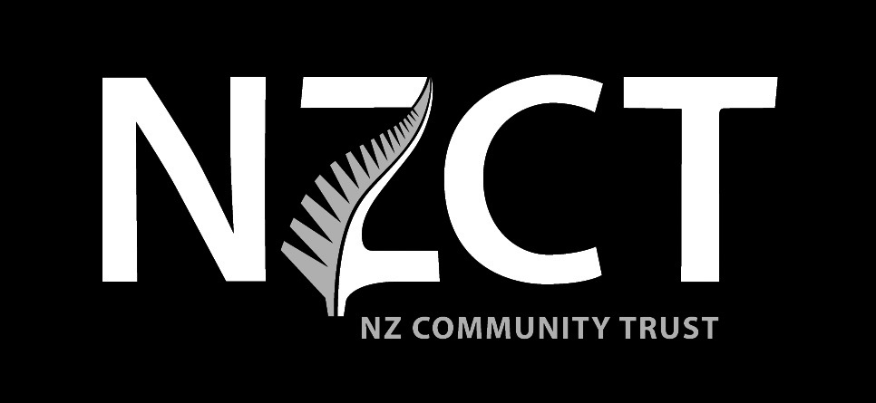

/ends

For more information or images, contact:

Roger Lloyd, CEO
t: 04 802 4047
e: ceo@nzyc.co.nz

Erica Challis, Publicist
t: 04 971 1853 / 021 102 6932
e: echallis@clear.net.nz

www.youthchoir.org.nz
Choirs Aotearoa New Zealand Trust
PO Box 11 046, Wellington 6142

